Teacher Dashboard - Functional Documentation

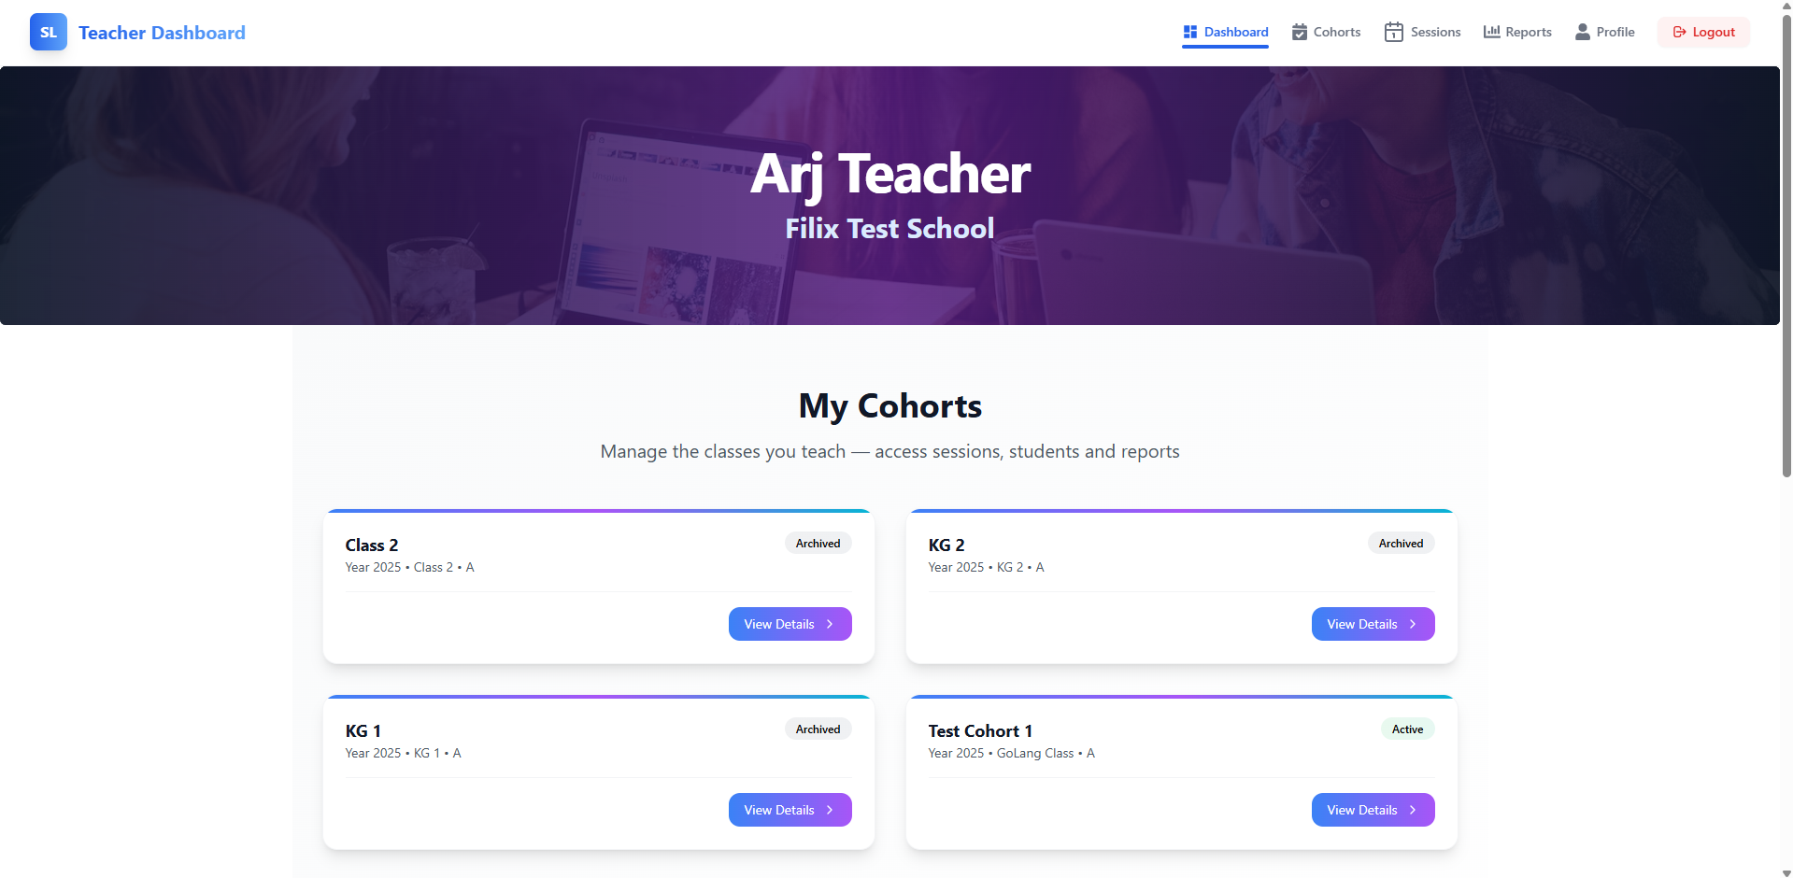

1. Overview
The Teacher Dashboard provides teachers with an intuitive interface to manage their cohorts, view detailed reports, and track progress. It includes access to cohort information, session schedules, and student performance data.

2. UI Sections

2.1 Header Section
The header section displays vital user information and offers easy navigation to other sections of the application.
- User Information:
  - Displays the teacher's name and role (e.g., Arj Teacher).
  - School name is shown next to the teacher’s name (e.g., Filix Test School).
- Navigation Bar:
  - Dashboard: This button redirects users to the main dashboard view.
  - Cohorts: Navigates to the section where all cohorts are listed.
  - Sessions: Takes the user to the session management page.
  - Reports: Opens the reports section where teachers can access session reports, student data, and other analytics.
  - Profile: Leads to the teacher's profile page for account management.
  - Logout: Logs the teacher out of the system and ends the session.

2.2 Main Section: My Cohorts
This section displays all the cohorts that the teacher is managing. Teachers can view the cohorts, their current status (active or archived), and the details associated with each cohort.
- Cohort Cards: Each cohort is displayed in a card format with the following information:
  - Cohort Name: Displays the cohort's name (e.g., Class 2, KG 1, Test Cohort 1).
  - Year: The academic year associated with the cohort (e.g., Year 2025).
  - Class Section: Indicates the specific class section (e.g., Class 2 - A).
  - Cohort Status: Displays whether the cohort is:
    - Active: Denotes a currently running cohort.
    - Archived: Denotes a cohort that has ended but is still accessible for reference.
- Action Buttons:
  - View Details: Each cohort card has a View Details button. Clicking this will redirect the teacher to the cohort details page, where they can view further information about students, sessions, and performance reports.

2.3 Cohort Cards Layout
- Grid Layout: The cohorts are presented in a grid. If the teacher manages many cohorts, the layout ensures that it remains neat and easily scrolled through.
  - Active cohorts are shown in the grid with a status badge labeled "Active."
  - Archived cohorts are also shown but marked with a "Archived" badge to indicate their status.
- Cohort Management Options:
  - Teachers can view, manage, and track their cohorts by using the View Details option.

2.4 Additional Features
- Cohort Detail Page:
By selecting View Details for a given cohort, the teacher can access:
  - Student List: A detailed list of students in the cohort.
  - Sessions: A section showing planned or completed sessions for that cohort.
  - Performance Reports: Analytics and performance data for the cohort, showing student attendance, grades, and progress.
- Cohort Status Management:
  - Teachers can manage the status of cohorts (e.g., activating new cohorts, archiving old cohorts).
  - Any cohort marked as "Archived" will not show up in active session views but can be accessed through the cohort list.

Cohort Management - Functional Documentation
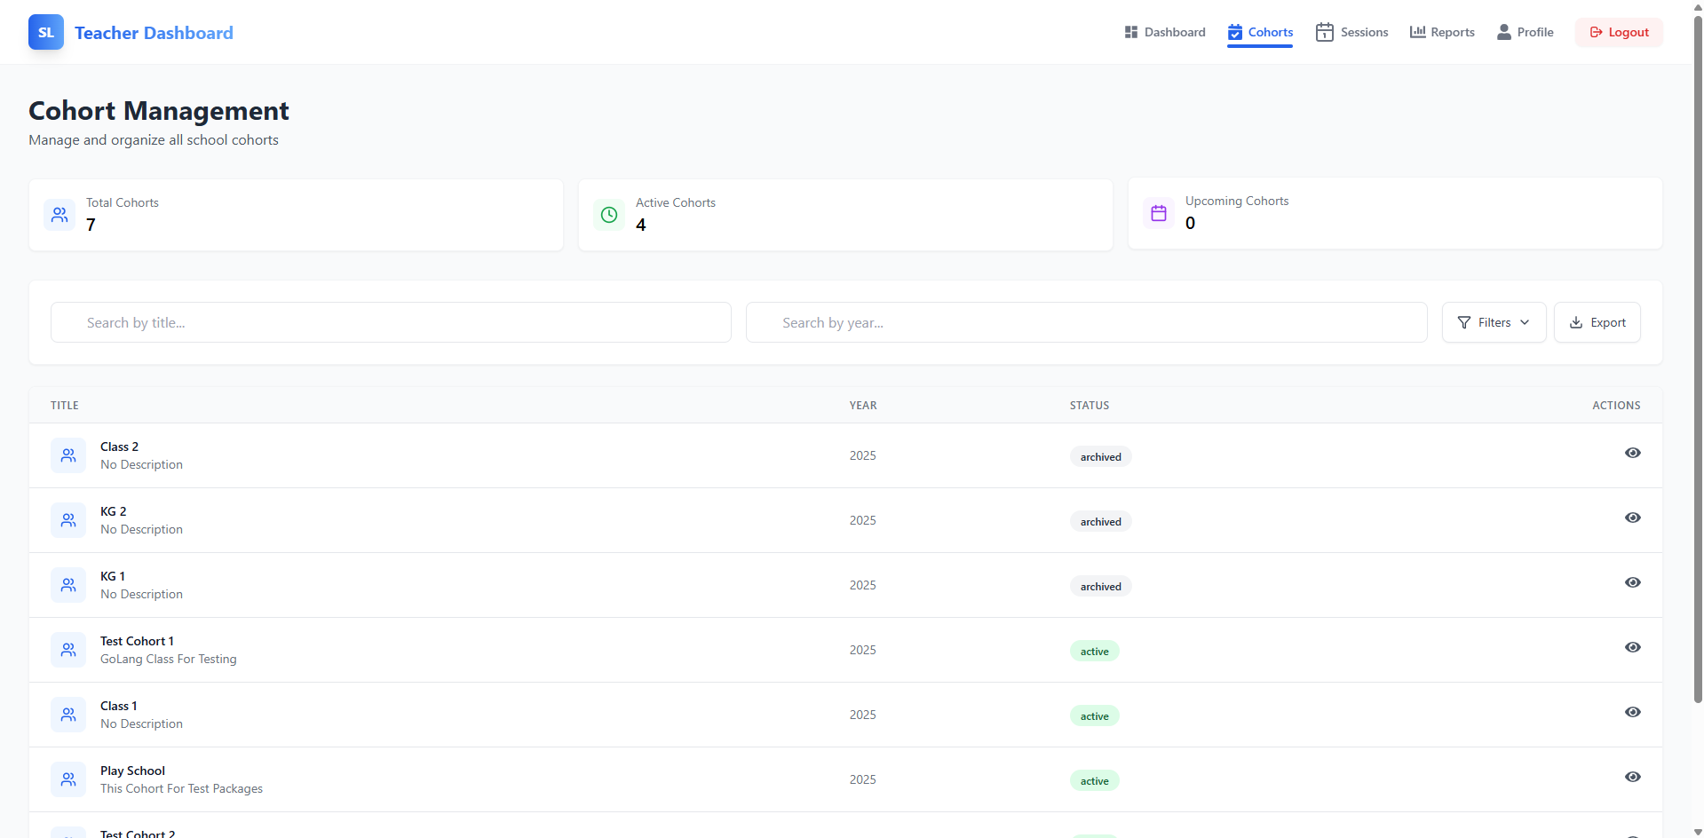

1. Overview
The Cohort Management page allows teachers to manage and organize all their school cohorts efficiently. It provides functionalities for viewing and filtering cohorts based on their status (active, archived), and other cohort-specific information. Teachers can view details about each cohort, manage descriptions, and more.

2. UI Sections

2.1 Header Section
The header section contains key information and actions to help navigate and manage cohorts effectively.
- Total Cohorts: Displays the total number of cohorts the teacher is managing.
- Active Cohorts: Shows the number of cohorts that are currently active.
- Upcoming Cohorts: Displays the number of cohorts scheduled to begin in the future.
- Search Bar:
  - Search by title: Allows the teacher to search for specific cohorts by their title.
  - Search by year: Enables the teacher to filter cohorts based on the academic year.

2.2 Cohort List
This section displays all the cohorts in a table format. Each cohort is represented by a row containing the following columns:
- Title:
  - The name of the cohort (e.g., Class 2, KG 2, Test Cohort 1).
  - If no description is added, it will show "No Description."
- Year:
  - The academic year in which the cohort is scheduled (e.g., 2025).
- Status:
  - Displays whether the cohort is Active, Archived, or any other status.
  - Active cohorts are highlighted with a green color.
  - Archived cohorts are displayed with a gray color.
- Actions:
  - Each cohort row has an Eye Icon to view detailed information about that cohort. Clicking the icon opens a detailed cohort view (student list, session management, etc.).

3. Cohort Management Workflow

3.1 Managing Active Cohorts
- Active cohorts are always displayed prominently in the list.
- Teachers can view and manage these cohorts by clicking the View Details button, which opens detailed information about the cohort, its students, and any sessions scheduled.

3.2 Managing Archived Cohorts
- Archived cohorts are clearly indicated and can be viewed for reference.
- Teachers can revisit these cohorts, review session details, and check student performance reports.

Session Manager - Functional Documentation

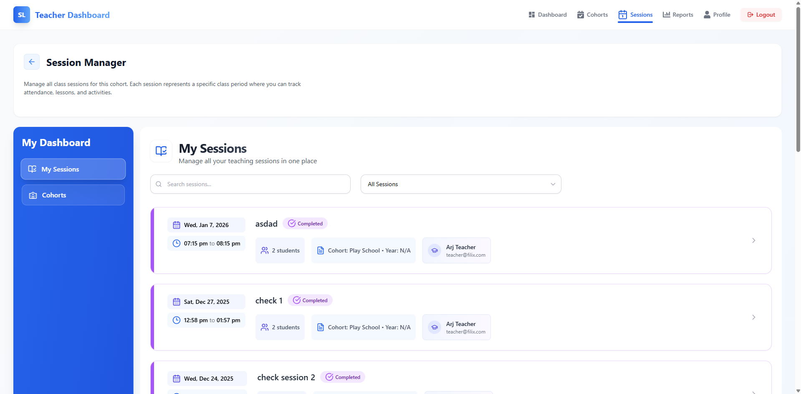

1. Overview
The Session Manager page enables teachers to manage and organize all their teaching sessions. A session represents a specific class period, where the teacher can track attendance, lessons, activities, and student participation. The page provides an overview of scheduled, completed, and upcoming sessions, along with relevant details such as session timings, cohorts, and the teacher's participation.

2. UI Sections

2.1 Header Section
- Page Title:
  - The title Session Manager appears at the top, indicating the functionality of managing class sessions.
- Subheading:
  - A brief description of the page functionality: "Manage all class sessions for this cohort. Each session represents a specific class period where you can track attendance, lessons, and activities."

2.2 Sidebar
- My Dashboard:
  - Contains navigation links:
    - My Sessions: Takes the teacher to the session manager page (current page).
    - Cohorts: Links to cohort management, where cohorts can be organized.
- Icons: Each section in the sidebar has intuitive icons for easy navigation.

2.3 Session List
This section displays the teacher's scheduled sessions in a table format, with each session represented by a row containing the following information:
- Session Details:
  - Date: The session’s date (e.g., Wed, Jan 7, 2026).
  - Time: The start and end times of the session (e.g., 07:15 pm to 08:15 pm).
  - Session Title: The title or name of the session (e.g., asdad, check 1, check session 2).
- Status:
  - Each session displays its current status, such as Completed.
  - Completed sessions are marked with a "Completed" label in a purple box.
- Participants:
  - Displays the number of students who attended the session (e.g., 2 students).
- Cohort:
  - Indicates the cohort associated with the session (e.g., Cohort: Play School).
- Teacher's Name and Email:
  - Shows the teacher's name (e.g., Arj Teacher) along with the teacher's email (e.g., teacher@flix.com).

3. Session Management Features

3.1 Session Filters
- Search Sessions:
  - A search bar allows the teacher to search for specific sessions by title. Teachers can quickly find specific sessions without needing to scroll through the list.
- Session Type Dropdown:
  - Teachers can filter sessions by type using the dropdown labeled All Sessions. This can help focus on specific sessions (e.g., Today’s sessions, Past Sessions, upcoming sessions).
- Session Actions:
  - Each session row includes a View More or similar action link (represented by an arrow), which provides access to the session’s detailed information.
  - Teachers can click this link to view or modify session details, add or remove students, track attendance, and access session notes.

Student Reports - Functional Documentation

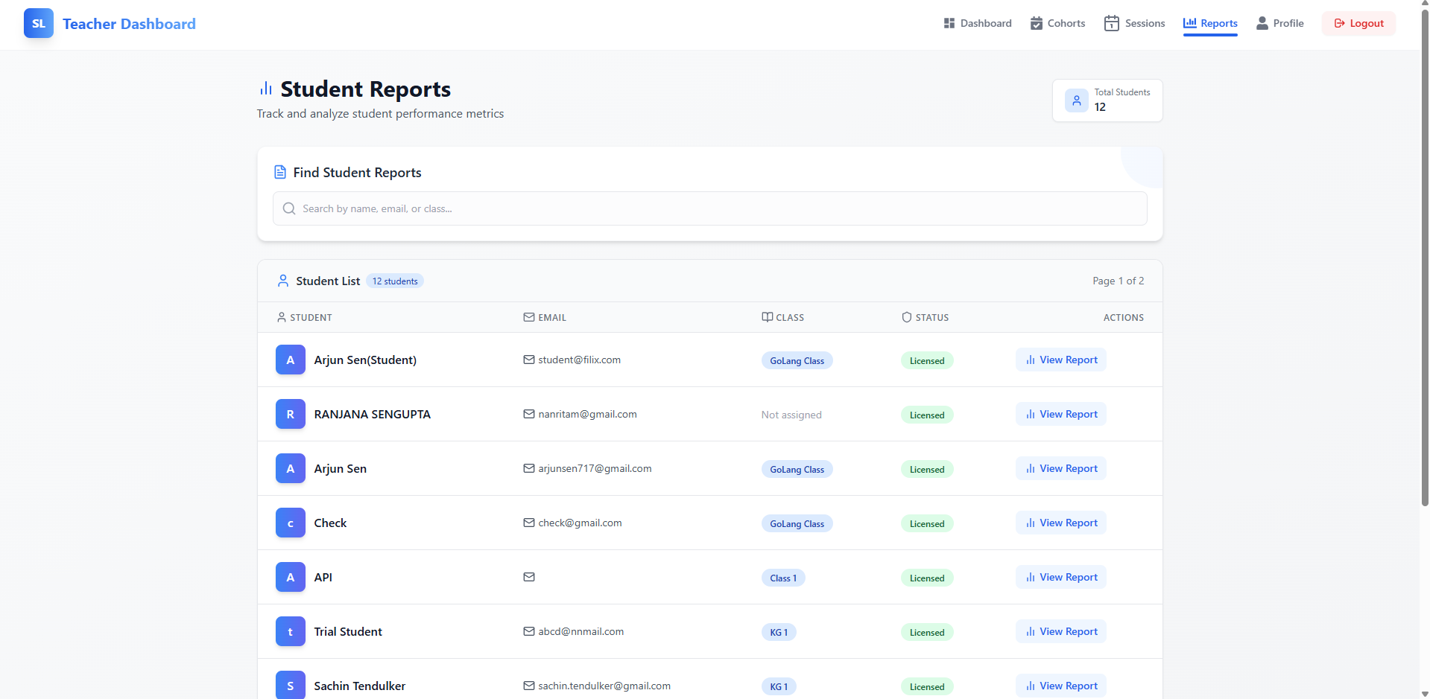

1. Overview
The Student Reports page enables teachers to track and analyze the performance metrics of their students. Teachers can view detailed reports for each student, including their status, assigned class, and performance data. The page offers an organized list of students, with quick access to individual reports.

2. UI Sections

2.1 Header Section
- Search Bar:
  - Find Student Reports: This search bar allows teachers to search for students by name, email, or class. It provides a quick way to locate a specific student's report from the list.
- Total Students:
  - Displays the total number of students available on the report list (e.g., 12 students).

2.2 Student List Section
This section displays a list of all students, organized in a table format. Each student entry contains the following information:
- Student Name:
  - Displayed prominently, with the student's name (e.g., Arjun Sen, Ranjana Sengupta, etc.).
  - If the student is associated with a cohort or class, it will be indicated next to the name.
- Email:
  - The student's email address (e.g., student@filix.com, arjunsen717@gmail.com).
- Class:
  - The class or cohort the student is assigned to (e.g., GoLang Class, Class 1, KG 1).
  - If a class is not assigned, this will be marked as Not assigned.
- Status:
  - The student's current status, such as Licensed, which indicates the student's enrollment status and whether they have access to the course materials.
- Actions:
  - View Report: A button that links to the detailed report of the student. When clicked, it opens a page with more in-depth performance metrics for the student.

3. Functionality Features

3.1 Search Functionality
- Search by Student:
  - Teachers can type in a student's name, email, or class in the search bar to quickly find a specific student’s report.
  - The results will dynamically filter as the teacher types, making it easier to locate students within large lists.

3.2 Student List Pagination
- Pagination Controls:
  - If there are too many students to fit on a single page, the list will be paginated.
  - Teachers can navigate between pages (e.g., Page 1 of 2) to see the complete list of students.

3.3 View Report Action
- View Report Button:
  - For each student, the View Report button allows teachers to access detailed performance data for that student.
  - Clicking the button opens a detailed report page where the teacher can review metrics such as attendance, grades, activity participation, and any notes related to the student's performance.

4. Report Management Workflow

4.1 Viewing Student Reports
- Teachers can click the View Report button next to a student's name to view their detailed performance report.
- The report includes insights such as:
  - Attendance records
  - Graded assignments
  - Completed activities and exercises
  - Any notes or feedback from the teacher

4.2 Searching and Filtering
- Teachers can search for specific students by name, email, or class using the search bar.
- The search bar dynamically filters results as the teacher types, allowing them to quickly find a student.

4.3 Viewing Multiple Students
- With pagination, teachers can view students across multiple pages, ensuring that even large numbers of students can be managed without overwhelming the interface.

Conclusion

1. Dashboard Page
- Overview: The dashboard acts as the central hub where teachers can quickly view key metrics such as active cohorts, upcoming sessions, and student-related data. It simplifies navigation to other pages (Cohorts, Sessions, Reports, etc.), providing a seamless experience.
- Key Functionality: Displays a high-level summary of tasks, saving time and reducing the need for constant page switching. Teachers can see all vital information in one place before diving into the more detailed sections.

2. Cohort Management
- Overview: The Cohort Management page helps teachers organize and manage the different cohorts they are responsible for. Teachers can view cohort status (active or archived), search and filter by title, and export the list for offline use.
- Key Functionality: This section allows teachers to manage cohort enrollment, update cohort statuses, and efficiently track which cohorts are currently active or archived. Teachers can access detailed information for each cohort, making it easier to stay on top of their class-related activities.

3. Session Management
- Overview: The Session Manager enables teachers to keep track of all the sessions they conduct for each cohort. The platform supports easy session management, including search, filter, and session status tracking (e.g., completed or upcoming).
- Key Functionality: Teachers can schedule and review session details, manage attendance, and track lesson progress. The search functionality helps them quickly find specific sessions, ensuring smooth and efficient class management.

4. Student Reports
- Overview: The Student Reports section provides teachers with detailed insights into individual student performance, including grades, attendance, and other performance metrics.
- Key Functionality: Teachers can search for students, view detailed reports, and monitor their progress. This functionality allows teachers to make data-driven decisions regarding student support and development.

